*Good afternoon, everyone. I’m number . My topic is .
*Good day, ladies and gentlemen. I’m number . I’m going to read .
*Hi, everybody. I’m number . I would like to read .

北門國小四年級英語朗讀比賽文章
G4 English Reading Competition Articles
- The Ants and the Grasshopper

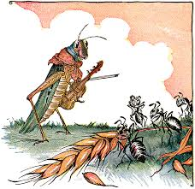

One bright day in late autumn a family of ants was rushing about in the warm sunshine. They had worked very hard all summer, gathering enough food to last during the cold winter months. Now they were drying out the grain and grass that they had saved. A starving grasshopper came up. He had his violin under his arm and begged very sadly for something to eat.

What?” the ants shouted as they worked. “You want us to give you something to eat? You should have worked hard all last summer to save enough food for the coming winter. What in the world were you doing with your time?”

“I did not have time to think about saving any food for the winter,” complained the grasshopper. “I was too busy making music and having fun. Before I knew it, the summer had come to an end.”

The ants were shocked at the grasshopper’s laziness.

“You were making music, were you?” they cried. “Very well; now you can dance!” Then they turned their backs on the grasshopper and went on with their work.

●Thank you for listening.
●Thank you, everyone.

*Good afternoon, everyone. I’m number . My topic is .
*Good day, ladies and gentlemen. I’m number . I’m going to read .
*Hi, everybody. I’m number . I would like to read .

北門國小四年級英語朗讀比賽文章
G4 English Reading Competition Articles
- The Bat and the Weasel

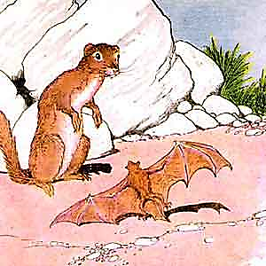

By mistake, a bat fell into the nest of a weasel, who rushed to catch and eat him. The bat begged for his life but the weasel would not listen.

“You are a mouse,” he said. “I am the enemy of mice. I eat every mouse I catch!”

“I am not a mouse!” cried the bat. “Look at my wings. Can mice fly? Why, I am only a bird! Please let me go!”

The weasel could see that the bat was not a mouse, so he let him go. A few days later, the foolish bat fell into the nest of another weasel. This weasel happened to be an enemy of birds. He quickly had the bat in his claws and was ready to eat him.

“You are a bird,” he said, “and I am going to eat you!”

“What,” cried the bat, “you think that I am a bird? Why, all birds have feathers! Oh, no, I am just a little mouse.”

The weasel could see that the bat was not a bird, and let him go. So, the bat saved his life a second time.

●Thank you for listening.
●Thank you, everyone.

