*Good afternoon, everyone. I’m number . My topic is .
*Good day, ladies and gentlemen. I’m number . I’m going to read .
*Hi, everybody. I’m number . I would like to read .

北門國小六年級英語朗讀比賽文章
G6 English Reading Competition Articles
- The Fox and the Crow

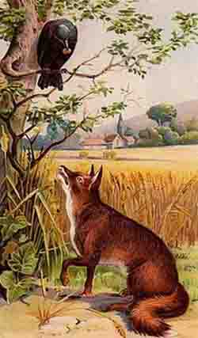

One day, a large black crow sat in a tree near a cottage. Through a window, she saw some cheese on a table. She quickly flew down, stole the cheese, and then flew back up into a high tree to eat it.

A sly, handsome fox was passing by. He noticed the crow. He sat down and began to praise her beauty. “You are very beautiful,” he said. “I have never seen such shiny black feathers. And you have the most perfect shape!” The crow was very vain, so she was delighted with the fox’s words.

The fox continued, “I think that you must have a lovely voice. Indeed, it must be as beautiful as you look. Surely no-one else can compete with you. Are you the Queen of the Birds?”

The crow was so pleased that she almost fell out of the tree with the cheese in her beak. Actually, she had never sung before but she thought, “This gentleman is very educated. I see that he knows a lot about beauty and good music.” Then she thought, “Yes, I can sing beautifully, but I am sure that this gentleman does not know how excellent my singing really is.” She was so excited that she decided to show him immediately. So, she opened her beak and began to croak as all crows do. At that moment, the cheese fell to the ground.

The sly fox snatched it up and ate it. When he had finished, he wiped his whiskers slowly and looked up at the crow. “Madam,” he said, “I have spoken about your beauty, but remember, I said nothing about your brains.”

●Thank you for listening.
●Thank you, everyone.
*Good afternoon, everyone. I’m number . My topic is .
*Good day, ladies and gentlemen. I’m number . I’m going to read .
*Hi, everybody. I’m number . I would like to read .

北門國小六年級英語朗讀比賽文章
G6 English Reading Competiotion Articles
- Belling the Cat

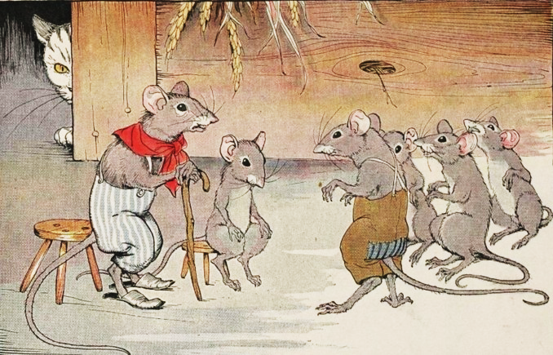

One day, the mice held a meeting to decide how they could free themselves of their enemy, the cat. She always seemed to be waiting to catch them, and that made them very nervous. They wanted to find some way of knowing when she was coming, so that they could have time to run away. Something had to be done because they lived all the time in terrible fear of her claws and teeth. They never felt safe, and they left their nests to get food only when they were very hungry.

At the meeting, many plans were discussed, but none of them was good enough. There was always some problem. At last a very young mouse stood up and said: "I have a plan. It is very simple, but I know it will be successful. The trouble is that we can never hear the cat coming towards us. She makes no noise with her soft paws. So, the matter is simple - all we have to do is to hang a bell around her neck. When we hear the bell ringing we will know immediately that our enemy is coming. That will give us time to escape."

All the mice were very excited about this new plan. They were really surprised that they had not thought of such an excellent plan before. Then, in the middle of their joy, an old mouse stood up to speak. He said: "Gentlemen, I will say that the plan of this young mouse is very good but, let me ask just one question: Who will be brave enough to hang the bell around the cat’s neck?"

●Thank you for listening.
●Thank you, everyone.

